MATH 4753 Laboratory 5

Random sampling
This lab will investigate random sampling. We will start with the R function sample(). This will introduce you to functions and how they can be very useful in simulation. The process of simulation utilizes random sampling and allows the statistician to trial theories in practice or to carry out analyses when there are no analytical results available. There are a number of discrete distributions that you can learn about in R. In this lab you will need to THINK through the code and understand the process.

Objectives
In this lab you will learn how to:
- Simulate from first principles.
- Use built in r-dist() functions.
- Make appropriate plots.

Tasks
All work is to be done on RMarkdown.
Upload completed:
- HTML
- RMD
Documents.
Note: All plots you are asked to make should be constructed through RMD and knitted into your html document

- Task 1
  - Make a folder LAB5
  - Download the file “lab5.r”
  - Place this file with the others in LAB5.
  - Start Rstudio
  - Open “lab5.r” from within Rstudio.
  - Go to the “session” menu within Rstudio and “set working directory” to where the source files are located.
  - Issue the function getwd()

- Task 2
  - Make a new file for your code in RStudio editor, call it “mylab5.R” and place in it all the code you need to answer the tasks of this lab (copy and paste from lab5.R).
  - Use the hash # symbol and write your own comments in the code file explaining what the code does.
  - Using code in lab5.R –mybin(), simulate a binomial experiment where n=10,p=0.7, and Y=number of successes. When running this particular function you will be carrying out iter experiments of making n=10 trials with the probability of a success p=0.7 and then recording the proportion of successes made over all the iterations. For example 1 success might happen on some iterations but it would have a low frequency over all the iterations, 7 successes would be more frequent and 10 less so.
Iter times
$$⋯$$
n=10
p=0.7
n=10
p=0.7
n=10
p=0.7
n=10
p=0.7

  - Record the plots for each of the following (Use color)
    - 100 iterations
    - 200 iterations
    - 500 iterations
    - 1000 iterations
    - 10,000 iterations
  - For the last simulation (10,000 iterations) copy and paste the table that is produced from the function.
  - Verify that each value in the table is approximately correct using dbinom() – you will need to look up the function using ?dbinom
- Task 3
  - Suppose that there is a bag of 20 marbles, 12 white (“1”) and 8 black “0”. Using the sample() function create a sample of size n=5 without replacement. Make sure this appears in your document
  - Now do the same with replace=TRUE.
  - Use the function myhyper(), on CANVAS, assume Y = number of whites, remember sampling is without replacement, n=5. Use this code to make barplots of Y for the following number of iterations
    - 100
    - 200
    - 500
    - 1000
    - 10,000
  - For the last simulation (10,000 iterations) copy and paste the table that is produced from the function.
  - Verify that each value in the table is approximately correct using dhyper()
- Task 4
  - In lab5.r there is a function called mysample(). Look at the code and describe what you think it should do – record your response here.
  - Run the function with the following arguments mysample(n=1000, iter=30,time=1)
  - Describe what you see here.
  - Make sure the plot appears in your document ( you need only include one of the 30 iterations)

- Task 5
  - Use R to calculate
    - $\left(\begin{matrix}8 \\ 4\end{matrix}\right)$ – hint: Try choose()
    - $P\left(Y>4\right), Y\sim Pois\left(λ=2\right)$
  - Some more calculations in R
    - $P\left(Y=10\right), Y\sim NegBin(p=0.4, r=3)$ see CANVAS which has a full explanation of this.
    - $P\left(Y≤8\right), Y\sim Bin\left(n=15,p=0.4\right)$
- Task 6 (AI)
  - For this lab “BETTER” means new and useful as before but this time “new” means new to AI. Or in the metaphor of class “beyond the frontier of mankind’s knowledge”. If you cannot do this then for less points define “new” to be new to this lab.
  - Create 2 R functions by copying code from this lab.
  - Improve them by thinking about what objects would be useful for the statistician:
    - Plots
    - Tables
    - These functions must create objects that are “BETTER” as defined above.
  - Say in what ways each function is:
    - New
    - Useful
  - Document the functions using roxygen
  - Create a new package example: MATH4753LABSWSTEF26 the package name must be unique. We will add functions to this for the current and subsequent labs, it will be referred to as “the Labs package”.
  - Package data that your functions can use.
  - Package the 2 functions and make sure they are well documented.
  - Create a vignette called “Lab5” and demonstrate what the functions do by using a data set and calling it with your functions
  - Install and restart the package using the icon in R studio
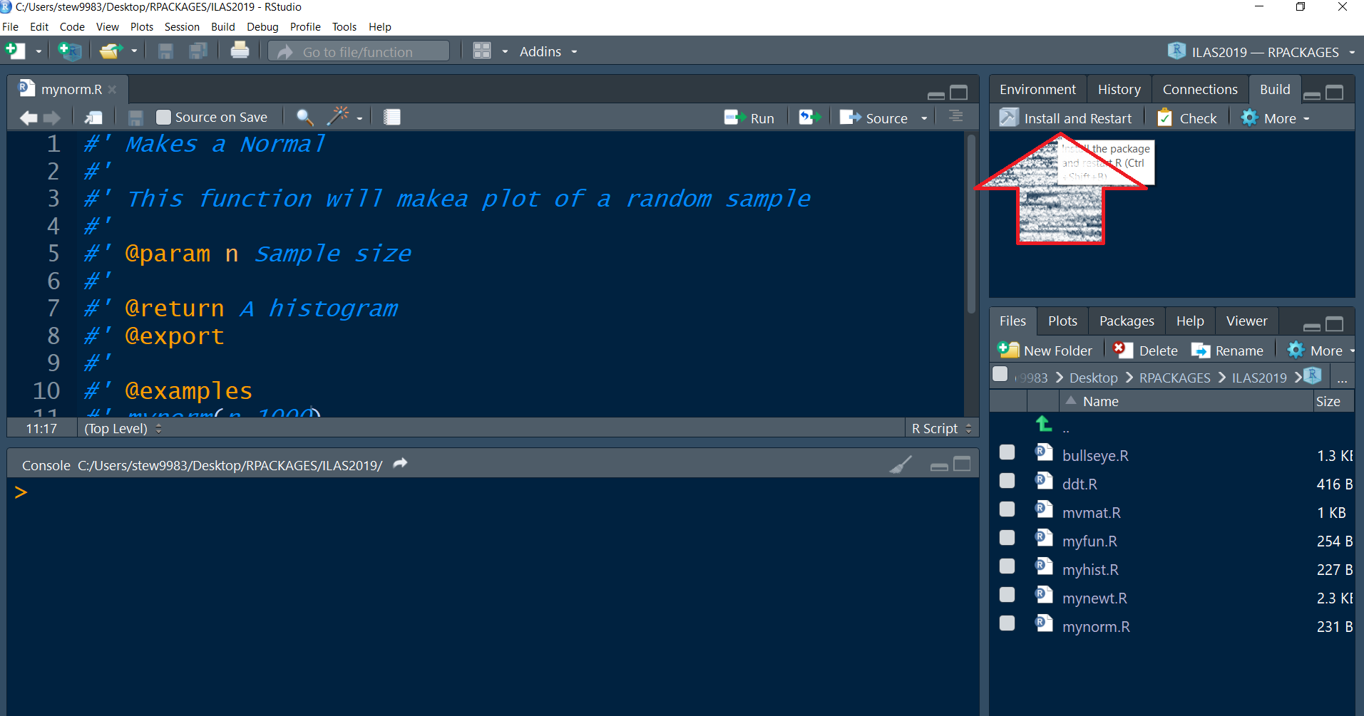
  - Invoke BOTH functions by doing the following – suppose one of your 2 functions is called myf()
Inside your R chunk for task 6 invoke the code:
yourpackage::myf()
Make sure myf() has the necessary arguments to run.
Upload to CANVAS the tar.gz package, a copy of the vignette you packaged
Place in the comments the last 10 lines of devtools::check() – you MUST have 000 to get full points.

MATH 4753 — Task 6 (AI) Grading Rubric (20 Points Total)
Performance Category | Points | Exemplary / Full Credit | Competent / Partial Credit | Developing / Deficient | Score
"BETTER": Novelty ("New") | 10 pts | Beyond the Frontier (9–10 pts)  • Introduces genuinely original, sophisticated functionality beyond standard AI boilerplate or basic textbook recipes.  • Demonstrates exceptional mathematical, computational, or algorithmic insight. | Beyond Lab 5 (5–8 pts)  • Implements extensions that are new relative to Lab 5 exercises, but follows standard, predictable, or routine patterns.  • Solid functional additions without significant creative leap. | Baseline / Minimal (0–4 pts)  • Superficial or trivial modifications (e.g., simple renaming, cosmetic color shifts).  • Does not move meaningfully beyond original lab code. | / 10
"BETTER": Utility ("Useful") | 5 pts | High Utility (5 pts)  • Returned objects (e.g., custom S3 classes, structured summary tables, publication-quality graphics) provide direct, actionable value for data analysis.  • Outputs are clean, well-formatted, and statistically informative. | Moderate Utility (3–4 pts)  • Additions provide useful summaries or visual improvements, but lack complete polish, thorough labeling, or rich diagnostic value. | Low / No Utility (0–2 pts)  • Outputs add negligible analytical value, are poorly formatted, uninformative, or difficult to interpret. | / 5
Roxygen2 Documentation & Vignette | 2 pts | Complete (2 pts)  • Full roxygen2 documentation for both functions (@title, @description, @param, @return, @export, working @examples).  • Working vignette named "Lab5" demonstrates both functions using packaged data. | Partial (1 pt)  • Documentation missing required tags, examples fail to run, or vignette lacks thorough demonstration with package data. | Unsatisfactory (0 pts)  • Minimal, broken, or missing roxygen2 headers and/or vignette. | / 2
RMD Namespace Execution & Data Packaging | 1 pt | Complete (1 pt)  • Both functions correctly invoked inside the RMD chunk via namespace: MATH4753LABSWSTEF26::myf(...).  • Sample dataset properly integrated into /data and usable by functions. | Partial (0.5 pts)  • Functions invoked without explicit package namespace, or minor data integration issue. | Unsatisfactory (0 pts)  • Functions fail to execute from the package; sample data omitted or unusable. | / 1
devtools::check() Validation | 2 pts | Clean Build: 0/0/0 (2 pts)  • Last 10 lines of devtools::check() pasted into submission comments.  • Confirms 0 errors, 0 warnings, 0 notes. | Minor Issues (1 pt)  • Check log shows 1 warning or note, or log snippet incomplete. | Errors / Missing (0 pts)  • Check errors present, package fails to build, or log omitted from comments. | / 2
TOTAL SCORE | 20 pts |  |  |  | / 20

Grader Evaluation & Notes
- Novelty / "Beyond the Frontier" Assessment:

- Statistical Utility & Practical Value:

- Package Integrity, Documentation & Check Log:

################### LAB FINISHES HERE ###############################

- Task 7 – Extra for experts
  - Write some code that will simulate a neg binomial distribution. You could use the while() condition

